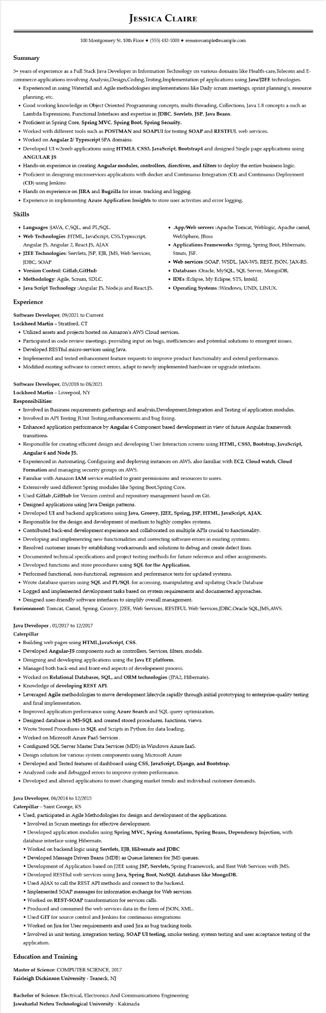
JESSICA CLAIRE
100 Montgomery St. 10th Floor⚫ (555) 432-1000⚫ resumesample@example.com
Summary
5+ years of experience as a Full Stack Java Developer in Information Technology on various domains like Health-care, Telecom and E- commerce applications involving Analysis, Design, Coding, Testing,Implementation pf applications using Java/J2EE technologies. • Experienced in using Waterfall and Agile methodologies implementations like Daily scrum meetings, sprint planning's, resource planning, etc.
• Good working knowledge in Object Oriented Programming concepts, multi-threading, Collections, Java 1.8 concepts a such as Lambda Expressions, Functional Interfaces and expertise in JDBC, Servlets, JSP, Java Beans.
• Proficient in Spring Core, Spring MVC, Spring Boot, Spring Security.
• Worked with different tools such as POSTMAN and SOAPUI for testing SOAP and RESTFUL web services.
• Worked on Angular 2/ Typescript SPA domains.
• Developed UI w2eeeb applications using HTML5, CSS3, JavaScript, Bootstrap4 and designed Single page applications using ANGULAR JS
• Hands-on experience in creating Angular modules, controllers, directives, and filters to deploy the entire business logic.
• Proficient in designing microservices applications with docker and Continuous Integration (CI) and Continuous Deployment (CD) using Jenkins
• Hands on experience on JIRA and Bugzilla for issue. tracking and logging.
• Experience in implementing Azure Application Insights to store user activities and error logging.
Skills
• Languages :JAVA, C,SQL, and PL/SQL.
• Web Technologies :HTML, JavaScript, CSS,Typescript, Angular JS, Angular 2, React.JS, AJAX
• J2EE Technologies: Servlets, JSP, EJB, JMS, Web Services, JDBC, SOAP
• Version Control: Gitlab,GitHub
• Methodology: Agile, Scrum, SDLC.
• Java Script Technology :Angular JS, Node.js and React.JS.
Experience
Software Developer, 09/2021 to Current
Lockheed Martin - Stratford, CT
• .App/Web servers :Apache Tomcat, Weblogic, Apache camel, WebSphere, JBoss
• Applications Frameworks :Spring, Spring Boot, Hibernate, Struts, JSF.
• Web services :SOAP, WSDL, JAX-WS, REST, JSON, JAX-RS.
• Databases :Oracle, MySQL, SQL Server, MongoDB,
• IDEs :Eclipse, My Eclipse, STS, InteliJ.
• Operating Systems :Windows, UNIX, LINUX.
• Utilized assets and projects hosted on Amazon's AWS Cloud services.
• Participated in code review meetings, providing input on bugs, inefficiencies and potential solutions to emergent issues. • Developed RESTful micro-services using Java.
• Implemented and tested enhancement feature requests to improve product functionality and extend performance.
• Modified existing software to correct errors, adapt to newly implemented hardware or upgrade interfaces.
Software Developer, 05/2018 to 08/2021
Lockheed Martin - Liverpool, NY
Responsibilities:
• Involved in Business requirements gatherings and analysis,Development, Integration and Testing of application modules.
• Involved in API Testing JUnit Testing, enhancements and bug fixing.
• Enhanced application performance by Angular 6 Component based development in view of future Angular framework transitions.
• Responsible for creating efficient design and developing User Interaction screens using HTML, CSS3, Bootstrap, JavaScript, Angular 6 and Node JS.
• Experienced in Automating, Configuring and deploying instances on AWS, also familiar with EC2, Cloud watch, Cloud Formation and managing security groups on AWS.
• Familiar with Amazon IAM service enabled to grant permissions and resources to users.
• Extensively used different Spring modules like Spring Boot,Spring Core.
• Used Gitlab,GitHub for Version control and repository management based on Git.
• Designed applications using Java Design patterns.
• Developed UI and backend applications using Java, Groovy, J2EE, Spring, JSP, HTML, JavaScript, AJAX.
• Responsible for the design and development of medium to highly complex systems.
• Contributed back-end development experience and collaborated on multiple APIs crucial to functionality.
• Developing and implementing new functionalities and correcting software errors in existing systems.
• Resolved customer issues by establishing workarounds and solutions to debug and create defect fixes.
• Documented technical specifications and project testing methods for future reference and other assignments.
• Developed functions and store procedures using SQL for the Application.
• Performed functional, non-functional, regression and performance tests for updated systems.
• Wrote database queries using SQL and PL/SQL for accessing, manipulating and updating Oracle Database
• Logged and implemented development tasks based on system requirements and documented approaches.
• Designed user-friendly software interfaces to simplify overall management.
Environment: Tomcat, Camel, Spring, Groovy, J2EE, Web Services, RESTFUL Web Services,JDBC,Oracle SQL,JMS,AWS.
Java Developer, 01/2017 to 12/2017
Caterpillar
• Building web pages using HTML, JavaScript, CSS.
• Developed Angular-JS components such as controllers, Services, filters, models.
• Designing and developing applications using the Java EE platform.
• Managed both back-end and front-end aspects of development process.
• Worked on Relational Databases, SQL, and ORM technologies (JPA2, Hibernate).
• Knowledge of developing REST API.
• Leveraged Agile methodologies to move development lifecycle rapidly through initial prototyping to enterprise-quality testing and final implementation.
• Improved application performance using Azure Search and SQL query optimization.
•
Designed database in MS-SQL and created stored procedures, functions, views.
• Wrote Stored Procedures in SQL and Scripts in Python for data loading.
• Worked on Microsoft Azure PaaS Services.
• Configured SQL Server Master Data Services (MDS) in Windows Azure IaaS.
• Design solution for various system components using Microsoft Azure
• Developed and Tested features of dashboard using CSS, JavaScript, Django, and Bootstrap.
• Analyzed code and debugged errors to improve system performance.
• Developed and altered applications to meet changing market trends and individual customer demands.
Java Developer, 06/2014 to 12/2015
Caterpillar - Saint George, KS
• Used, participated in Agile Methodologies for design and development of the applications.
• Involved in Scrum meetings for effective development.
•Developed application modules using Spring MVC, Spring Annotations, Spring Beans, Dependency Injection, with
database interface using Hibernate.
• Worked on backend logic using Servlets, EJB, Hibernate and JDBC
• Developed Message Driven Beans (MDB) as Queue listeners for JMS queues.
• Development of Application based on J2EE using JSP, Servlets, Spring Framework, and Rest Web Services with JMS.
• Developed RESTful web services using Java, Spring Boot, NoSQL databases like MongoDB.
• Used AJAX to call the REST API methods and connect to the backend.
• Implemented SOAP messages for information exchange for Web services.
• Worked on REST-SOAP transformation for services calls.
• Produced and consumed the web services data in the form of JSON, XML.
• Used GIT for source control and Jenkins for continuous integrations
• Worked on Jira for User requirements and used Jira as bug tracking tools.
• Involved in unit testing, integration testing, SOAP UI testing, smoke testing, system testing and user acceptance testing of the
application.
Education and Training
Master of Science: COMPUTER SCIENCE, 2017
Fairleigh Dickinson University - Teaneck, NJ
Bachelor of Science: Electrical, Electronics And Communications Engineering
Jawaharlal Nehru Technological University - Kakinada

